Homework3.R

Chris

Fri Apr 22 14:28:00 2016

####################################################################  
# Pharm 609 Homework 3  
# Yaowen Mei (20470193)  
# Question 1  
####################################################################  
# Read a csv file  
library(stats4)  
library(MASS)  
library(pander)  
library(lattice)  
library(survival)  
library(Formula)  
library(ggplot2)  
library(Hmisc)

##   
## Attaching package: 'Hmisc'

## The following objects are masked from 'package:base':  
##   
## format.pval, round.POSIXt, trunc.POSIXt, units

library(corrplot)  
library(matrixStats)

## matrixStats v0.50.1 (2015-12-14) successfully loaded. See ?matrixStats for help.

library(varhandle)  
library(nlme)  
  
  
data <- read.csv("CIPROFLOXACIN.csv")  
head(data)

## ID TIME AMT DV RATE AGE WT GEND  
## 1 1 0.000 73 0.00 73 0.67 7.2 2  
## 2 1 0.583 0 4.16 0 0.67 7.2 2  
## 3 1 1.000 0 6.86 0 0.67 7.2 2  
## 4 1 1.849 0 2.96 0 0.67 7.2 2  
## 5 1 3.000 0 2.11 0 0.67 7.2 2  
## 6 1 3.917 0 1.77 0 0.67 7.2 2

data$GEND <- factor(data$GEND,levels=c(1,2),  
 labels=c("male","female"))  
  
data <- groupedData(DV~TIME|ID,data = data)  
data.sub = gsummary(data)  
data.sub1 = gsummary(data, inv=T)  
data.sub1

## ID AGE WT GEND  
## 6 6 0.32 4.2 female  
## 17 17 1.25 14.3 female  
## 7 7 0.27 4.8 female  
## 4 4 0.67 9.3 female  
## 2 2 0.42 8.9 male  
## 12 12 1.25 11.0 male  
## 16 16 1.75 12.0 female  
## 14 14 1.55 11.3 female  
## 19 19 1.54 11.1 male  
## 1 1 0.67 7.2 female  
## 8 8 0.38 7.2 male  
## 9 9 0.99 12.1 male  
## 15 15 4.54 23.2 female  
## 20 20 1.27 13.7 male  
## 13 13 1.00 10.7 female  
## 18 18 1.23 13.1 female  
## 10 10 0.33 6.2 female  
## 3 3 0.33 5.4 female  
## 5 5 0.36 6.9 female  
## 11 11 4.75 19.5 female

plot(data)

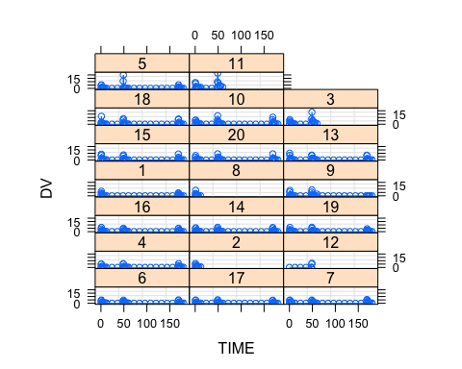

sort(table(data$ID))

##   
## 12 2 8 11 3 1 7 20 6 17 4 16 14 19 9 15 13 18 10 5   
## 8 9 9 21 22 32 40 40 41 41 41 41 41 41 41 41 41 41 41 41

table(data$GEND)

##   
## male female   
## 148 525

sapply(data.sub[,c("WT","AGE")],summary)

## WT AGE  
## Min. 4.200 0.270  
## 1st Qu. 7.125 0.375  
## Median 10.850 0.995  
## Mean 10.600 1.244  
## 3rd Qu. 12.350 1.338  
## Max. 23.200 4.750

table(data.sub$GEND)

##   
## male female   
## 6 14

#demographic characteristics  
par(mfrow=c(1,3))  
par(mar=c(4,4,2,2))  
hist(data.sub$WT, main='Weight Histogram', xlab='Weight(kg)')  
hist(data.sub$AGE,main='Age Histogram', xlab='Age(years)')  
boxplot(DV~GEND,xlab="Sex", ylab="Concentration (mg/L)", names=c("Males","Females"),data=data.sub)  
mtext("n.male=6, n.male=14",side=3)

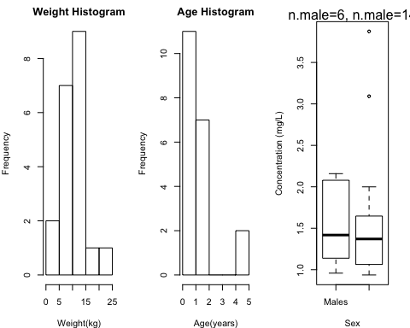

# Print the corralation table:  
dat <- subset(data.sub, select = -c(ID, GEND,RATE,AMT,DV, TIME))  
cor_table = rcorr(as.matrix(dat),type= 'pearson')  
plot(dat)  
cor_table$r

## AGE WT  
## AGE 1.0000000 0.9104811  
## WT 0.9104811 1.0000000

cor_table$P

## AGE WT  
## AGE NA 2.524298e-08  
## WT 2.524298e-08 NA

